

MATLAB ASSIGNMENT

NAME | REG-NUMBER
WANDERA MARY VIVIAN | BU/UP/2025/3135
MASIKA RIHANAH | BU/UG/2025/4416
WAMBWA DAN NYOTE | BU/UP/2025/3134
NAKAUMA PROSSY | BU/UP/2025/1972
OONYU LAWRENCE | BU/UP/2025/3132
GROUP ONE
1.Secant Method
The Secant method finds a root of f(x) = 0 without needing the derivative. It starts with two guesses and replaces the tangent line of Newton's method with the secant line through the last two points.
x(n+1) = x(n) - f(x(n)) * (x(n) - x(n-1)) / ( f(x(n)) - f(x(n-1)) )

example;
Solve f(x) = cos(x) - x = 0 with x0 = 0, x1 = 1, tolerance = 0.000001, N = 20.
i | x(i-1) | x(i) | f(x(i-1)) | f(x(i)) | x(i+1) | error
1 | 0.000000 | 1.000000 | 1.000000 | -0.459698 | 0.685073 | 3.15e-01
2 | 1.000000 | 0.685073 | -0.459698 | 0.089299 | 0.736299 | 5.12e-02
3 | 0.685073 | 0.736299 | 0.089299 | 0.004660 | 0.739119 | 2.82e-03
4 | 0.736299 | 0.739119 | 0.004660 | -0.000057 | 0.739085 | 3.42e-05
5 | 0.739119 | 0.739085 | -0.000057 | 0.000000 | 0.739085 | 2.11e-08

Root x = 0.739085 (found after 5 iterations)

Pseudocode
FOR loop version
INPUT x0, x1, tol, N
FOR i = 1 TO N
x2 = x1 - f(x1)*(x1-x0)/(f(x1)-f(x0))
IF |x2 - x1| < tol THEN
PRINT x2
STOP
END IF
x0 = x1
x1 = x2
END FOR
PRINT x2 (last estimate)

WHILE loop version
INPUT x0, x1, tol, N
i = 1
err = 1
WHILE err > tol AND i <= N
x2 = x1 - f(x1)*(x1-x0)/(f(x1)-f(x0))
err = |x2 - x1|
x0 = x1
x1 = x2
i = i + 1
END WHILE
PRINT x1

Flowchart: FOR loop
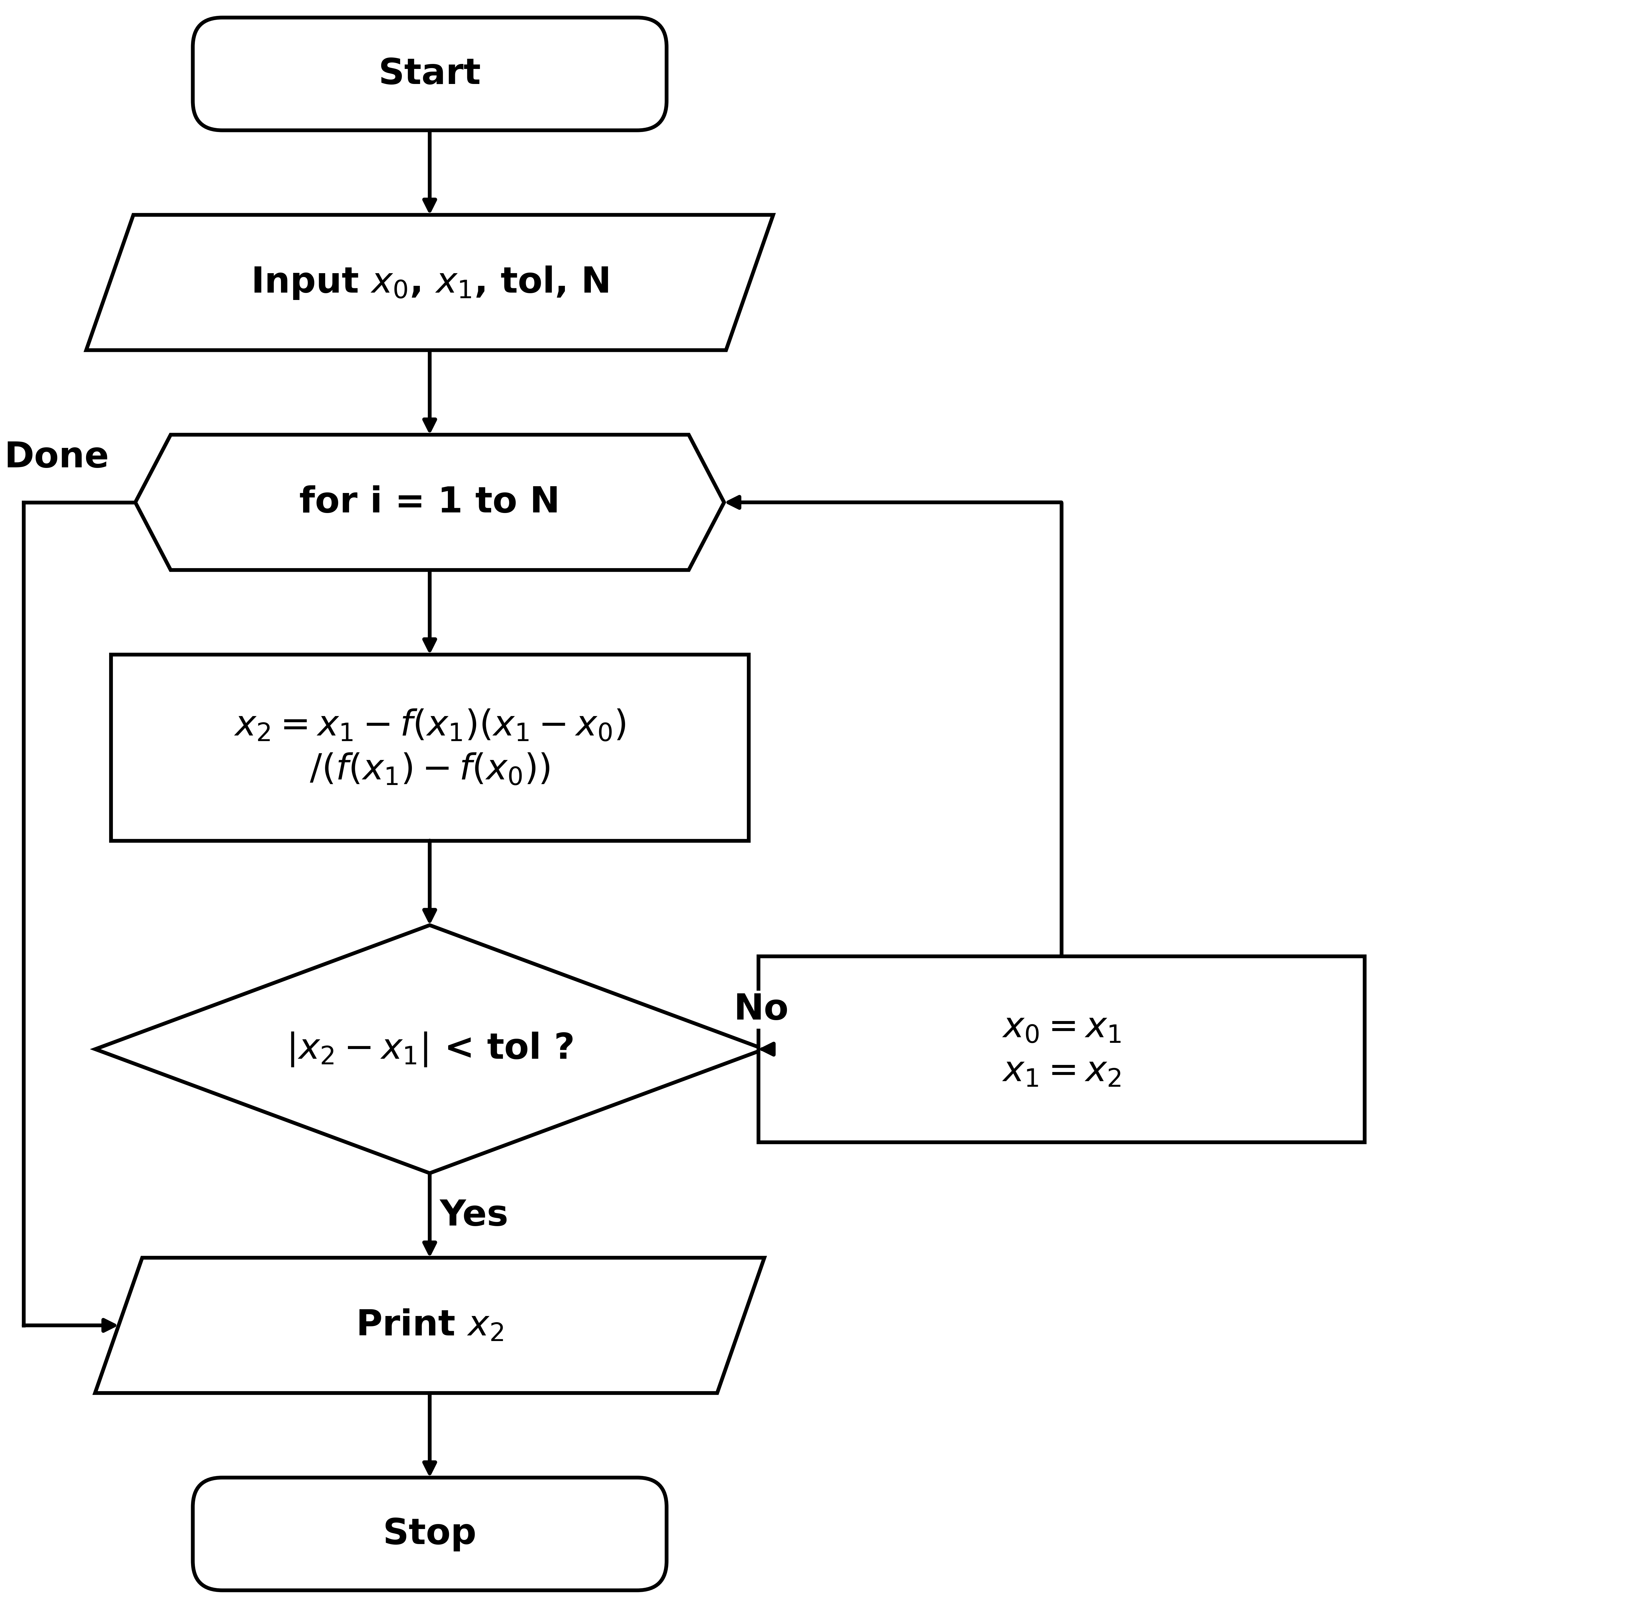

Flowchart: WHILE loop
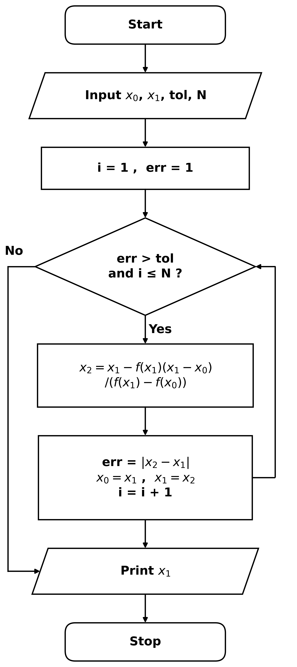

2.Runge-Kutta Method (4th order)
Runge-Kutta (RK4) solves a first-order differential equation
dy/dx = f(x, y) with y(x0) = y0. At every step it takes four slope estimates (k1 to k4) and uses their weighted average to move from x to x + h.
k1 = f(x, y)
k2 = f(x + h/2, y + h*k1/2)
k3 = f(x + h/2, y + h*k2/2)
k4 = f(x + h, y + h*k3)
y(new) = y + h*(k1 + 2*k2 + 2*k3 + k4)/6

example
Solve dy/dx = x + y, y(0) = 1 with step size h = 0.1 and find y(0.2). Exact solution: y = 2e^x - x - 1.
step | x | y | k1 | k2 | k3 | k4 | y(new)
1 | 0.0 | 1.000000 | 1.000000 | 1.100000 | 1.105000 | 1.210500 | 1.110342
2 | 0.1 | 1.110342 | 1.210342 | 1.320859 | 1.326385 | 1.442980 | 1.242805

y(0.2) = 1.242805
exact = 1.242806
error = 3.75e-07

Pseudocode
FOR loop version
INPUT x0, y0, h, n
x = x0 ; y = y0
FOR i = 1 TO n
k1 = f(x, y)
k2 = f(x + h/2, y + h*k1/2)
k3 = f(x + h/2, y + h*k2/2)
k4 = f(x + h, y + h*k3)
y = y + h*(k1+2*k2+2*k3+k4)/6
x = x + h
END FOR
PRINT y

WHILE loop version
INPUT x0, y0, h, xn
x = x0 ; y = y0
WHILE x < xn
k1 = f(x, y)
k2 = f(x + h/2, y + h*k1/2)
k3 = f(x + h/2, y + h*k2/2)
k4 = f(x + h, y + h*k3)
y = y + h*(k1+2*k2+2*k3+k4)/6
x = x + h
END WHILE
PRINT y

Flowchart: FOR loop
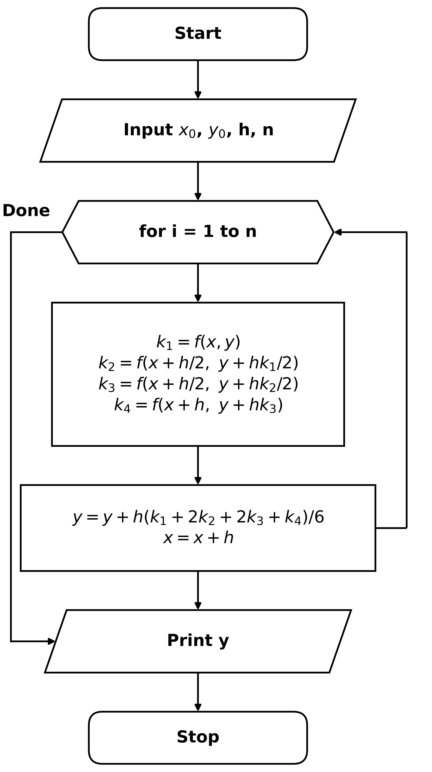

Flowchart: WHILE loop
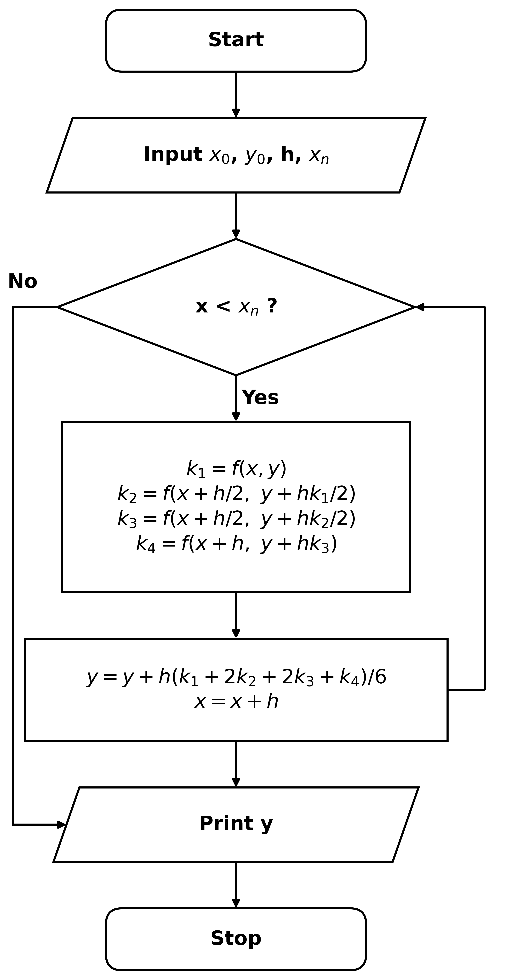

3. Newton-Raphson Method
Newton-Raphson finds a root of f(x) = 0 using the derivative. From a guess x0 it follows the tangent line down to the x-axis, and repeats until the change is smaller than the tolerance.
x(n+1) = x(n) - f(x(n)) / f'(x(n))

example
Solve f(x) = x^3 - 2x - 5 = 0 with f'(x) = 3x^2 - 2, x0 = 2, tolerance = 0.000001, N = 20.
i | x(i) | f(x(i)) | f'(x(i)) | x(i+1) | error
1 | 2.000000 | -1.000000 | 10.0000 | 2.100000 | 1.00e-01
2 | 2.100000 | 0.061000 | 11.2300 | 2.094568 | 5.43e-03
3 | 2.094568 | 0.000186 | 11.1616 | 2.094551 | 1.66e-05
4 | 2.094551 | 0.000000 | 11.1614 | 2.094551 | 1.56e-10

Root x = 2.094551 (found after 4 iterations)

Pseudocode
FOR loop version
INPUT x0, tol, N
FOR i = 1 TO N
x1 = x0 - f(x0)/f'(x0)
IF |x1 - x0| < tol THEN
PRINT x1
STOP
END IF
x0 = x1
END FOR
PRINT x1 (last estimate)

WHILE loop version
INPUT x0, tol, N
i = 1
err = 1
WHILE err > tol AND i <= N
x1 = x0 - f(x0)/f'(x0)
err = |x1 - x0|
x0 = x1
i = i + 1
END WHILE
PRINT x0

Flowchart: FOR loop
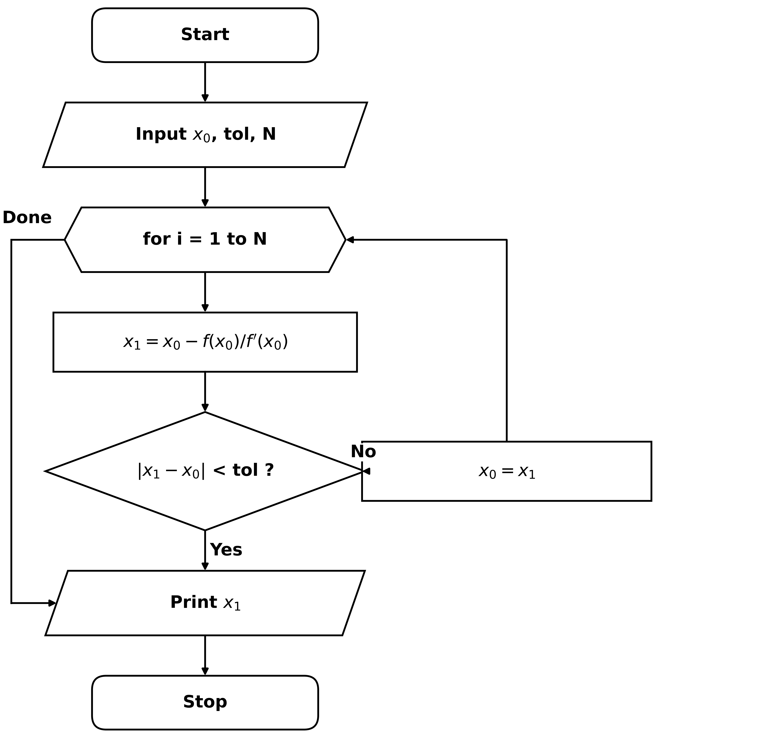

Flowchart: WHILE loop
